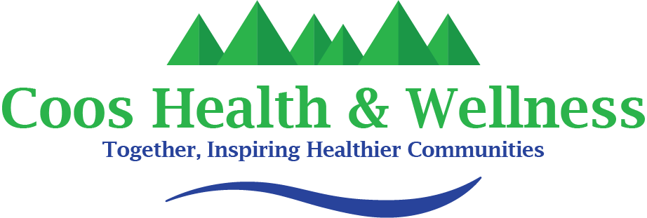

COOS HEALTH & WELLNESS- PUBLIC HEALTH
Strategic Plan

Adopted 11/2023 Expected Implementation 12/2028

Table of Contents

Strategic Planning Process 4

Public Health Modernization 6

DRAFT Strategic Issues and Priorities 9

Alignment with Overall Agency Goals 11

Strategic Priorities 12

Strategic Planning Process
The Coos Health & Wellness Public Health Division (CHWPHD) completed a 5-year strategic plan in July and August of 2023 to span the years of 2023 to 2028. The plan was developed by the CHWPHD leadership team with input from Public Health staff.
In July of 2023, all CHWPHD staff and managers were invited to participate in a survey to assess strengths, weaknesses, opportunities, and threats (SWOT) and Rede received 15 responses. SWOT data was used in a strategic planning session to identify strategic issues and priorities.
The strategic planning session took place in Bandon, OR on August 28, 2023, and was attended by the Public Health leadership team including Anthony Arton, Cynthia Rodriguez, Kathy Cooley, Katrinka McReynolds, Katie Tobiska, Lena Hawtin, Rick Hallmark, and Rose Atencio-le. After a brief introduction to the purpose and goal of strategic planning, participants reviewed data from the SWOT survey and discussed key themes. These themes were used to identify and prioritize strategic goals for CHWPHD. Once three strategic priorities had been identified, the group broke for lunch and then came back together in a round robin activity to develop goals, objectives, and actions under each strategic priority. The Public Health Modernization Framework was also used to guide the development of strategic priorities and discuss the groups vision for CHWPHD.

Utilizing the Strategic Plan
A strategic plan determines what the division plans to achieve and how to achieve it. CHWPHD will utilize this strategic plan to direct the divisions development and capacity-building over the next five years, evaluate their progress, and then replan another five-year Strategic Plan in 2028. The shared understanding of the mission, vision, goals, and objectives among CHWPHD managers, staff, and partners will guide priorities and decision-making in programs and for the division as a whole.
Mission (CHWPHD):  Public Health at Coos Health & Wellness informs and protects our local communities from diseases, ensures local restaurants, pools, and other facilities are safe for public use, as well as provides dental checkups, immunization programs, and other preventative services. | Vision (CHW):  Together, inspiring healthier communities.

Public Health Modernization
During the strategic planning session, the public health modernization framework was used as a guide to elevate strategic priorities for CHWPHD.
In 2013, the Oregon State Legislature passed legislation creating the Task Force on the Future of Public Health Services. The Task Force was responsible for developing recommendations for the future of public health in Oregon. The recommendations created by the Task Force envisioned a modern public health system that offers foundational public health programs and capabilities in communities across Oregon.
The goals of modernization are: every Oregonian has access to vital public health services to keep them healthy, reduce the need for costly medical care, and ensure children are ready to learn before entering a classroom.
In 2015, the Legislature passed legislation, based on the findings of the Task Force, to establish a framework and funding for moving forward with the modernization of public health in Oregon. In 2016, after an assessment of Oregon’s public health system identified a need to invest in public health modernization, a portion of a $60.6 million legislative investment allowed local public health authorities to begin modernization work.
Modernization work includes:
- Collecting comprehensive environmental health data to identify and mitigate risks to health and disproportionate impacts to communities experiencing racism, oppression and systemic under-investment.
- Identifying the top environmental health risks and the people most exposed to those risks at the state and community level, with a focus on risks intensified by rapidly accelerating climate change.
- Developing local and regional strategies that support equitable climate adaptation to increased fire, smoke, heat, floods, drought, water-borne disease and vector-borne disease. For example, establishing community smoke alert systems and options for vulnerable people to avoid wildfire smoke exposure. More broadly, identifying opportunities to maximize health co-benefits in land use, transportation, housing, energy, food and other systems shaped by public policies and investments.
- Investing in communities to co-create solutions to climate and other environmental public health issues in ways that are culturally relevant and linguistically appropriate and address the community’s priorities
- Increasing local and regional environmental hazard preparedness planning, community engagement, and response capacity including proactive and timely risk communications
- Partnership across state agencies to promote environmental health co-benefits of state natural resource, land use, built environment and other environmental policies and programs.

Oregon’s modernization framework includes foundational programs, which, when they are staffed with professionals with skills in foundational capabilities, can meet the needs of the community (see Fig 1).
The graphic below is a visual of the public health modernization framework as defined by the Oregon Health Authority.
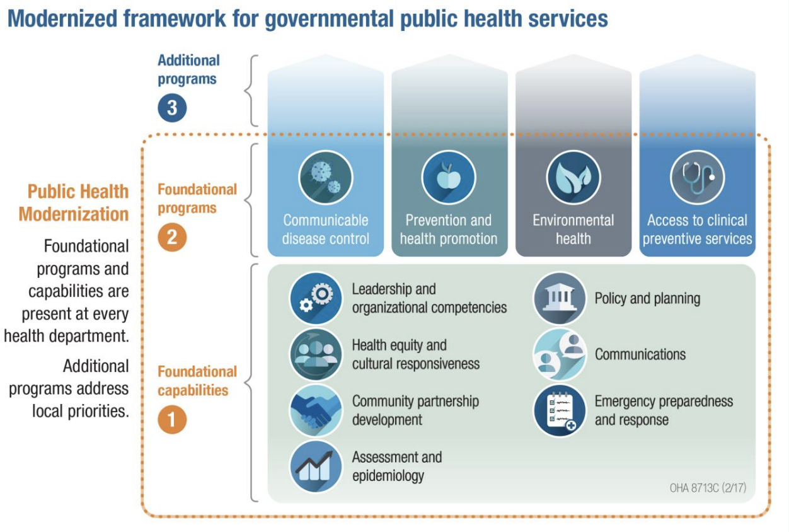
Learn more about public health modernization in Oregon here.

DRAFT Strategic Issues and Priorities
The National Association of City and County Health Officials (2016) defines strategic issues as, “fundamental policy questions or critical challenges that must be addressed in order for an LHD to achieve its mission.” Based on information gathered during July and August 2023, the CHWPHD leadership team identified three strategic issues facing the organization.

Strategic Issues Identified for CHWPHD:
- Community relationships and trust: Over the past three years, and largely attributable to the COVID-19 pandemic response, a lack of trust in governmental public health has degraded the public’s relationship with Public Health in the United States. At the same time, the pandemic highlighted health inequities: People experiencing inequities may also be distrustful of government. A lack of trust in Public Health poses a serious risk to the public’s health as individuals, families, and community groups may question CHWPHD’s ability to deliver critical public health protections or, worse, assume that CHWPHD is not working in their best interest.
- Resources and capacity: CHWPHD lacks the funding to fully realize its mission. Specifically, data and communication functions that are essential to building community trust, preventing disease, and reversing health inequities are significantly under-resourced. These resource gaps pose a serious risk to the public's health. Without vital communication and data infrastructure, CHWPHD lacks the ability to fully understand and effectively inform the public about health risks.
- Internal (CHWPHD) alignment on mission and strategic focus: CHWPHD staff served admirably through the extended public health crisis of COVID-19. Years of working in crisis mode invariably impacts organizational cohesion and alignment around the broader mission. In the wake of the pandemic and adjacent changes, reclaiming the agency's identity, redefining strategic focus, and unifying staff around the mission and focus are critical steps to optimal organizational performance.

Strategic Priorities:
- Strengthen community relationships with CHWPHD to build trust across different communities in Coos County.
- Work with partners to seek and sustain funding for critical public health services while increasing staff capacity and efficiency by utilizing technology
- Ensure that all CHWPHD staff understand the role and current focus of CHWPHD and are able to contribute collectively to achieving CHWPHD’s strategic plan and CHW’s mission.

Alignment with Overall Agency Goals
CHWPHD is a division within Coos Health and Wellness (CHW). CHW’s overall agency goals include:
- Improving the client experience
- Staff development and retention
- Sustainability of programs
- Utilizing data and metrics
The strategic priorities in this plan are aligned with these larger agency goals, so that progress on the strategic priorities of CCPH will contribute to the achievement of CHW’s overall agency goals.
CHWPHD Strategic Priority | Agency (CHW) Goal
Strengthen community relationships to build trust across different communities in Coos County. | ⇒ Improving the client experience
Work with partners, to seek and sustain funding for critical public health services while increasing staff capacity and efficiency by utilizing technology | ⇒ Sustainability of programs  ⇒ Utilize data and metrics
Ensure that all CHWPHD staff understand the role and current focus of CCPH and are able to contribute collectively to achieving CHWPHD’s Strategic Plan and CHW’s Mission. | ⇒ Staff development & retention  ⇒ Utilize data and metrics

Strategic Priorities

Strategic Priority 1: Strengthen community relationships to build trust across different communities in Coos County. (Oregon FPHS Capability)
Goal 1: Increase and improve relationships with health-related organizations, organizations representing populations experiencing health inequities, private businesses, faith based communities, and community based organizations and federal, tribal, state and local government agencies and non-elected officials. (Oregon FPHS Capability)
- Objective: By December 2024, add divisional position to strengthen community partnerships. (Note: this objective ties to Strategic Priority 3, in alignment with CHWPHD mission, programs and services will build staff capacity to effectively represent CHWPHD with partners and individuals).
- Metric: Staff position created
- Objective: By January 2024, identify key partner meetings that relate to CHWPHD programs and ensure CHWPHD representation occurs.
- Metric: List of partners meetings for CHWPHD can attend.
- Objective: By December 2025 develop internal processes and tools to ensure a coordinated approach to partner engagement and that CHWPHD representatives are able to comprehensively promote CHWPHD’s mission and programs with aligned communication.
- Metric: Create spreadsheet and verbal expectations, assign management staff, and discuss at leadership team meetings for planning and gain feedback.
Goal 2: Utilize Community Health Assessment, Community Health Improvement Plan, County Health Rankings, Oregon Modernization framework, data and goals to educate and collaborate relevant community partners.
- Objective: By January 2025, utilize new position to disseminate and gain feedback from community partners.
- Metrics: Assessment results, and improved numbers in program services and county health rankings.
  - Action: Review assessment results and create a plan for addressing partner relations issues and gaps (by December 2024)
  - Action: Review partner assessment bi-ennially.
Goal 3: Develop and implement communication strategies to increase visibility of CHWPHD and to ensure systems are in place to reach targeted populations with information about specific public health issues and potential risks. (Oregon FPHS Capability)
- Objective: By June 2024, create and begin implementation of a CHWPHD awareness campaign utilizing various forms of media; the communication plan should include objectives noted in this goal. Objectives below. “You are Public Health” campaign
- Metrics: Plans, placement, and reach numbers.
- Objective: By December 2025, improve social media reach (coverage and intensity) to populations CHWPHD is trying to engage.
- Metrics: Each Public Health Program creates at-least 2 engaging social media content material monthly.
    - Action: Identify target populations, tailoring messages to be culturally sensitive and community-specific (by June 2025).
    - Action: Create plans for increased message frequency while determining which platforms are most appropriate for reaching each targeted population with specific objectives and timelines (by June 2025).
    - Action: Implement social media marketing by creating a monthly social media calendar that outlines the content, schedule, and key messaging for each targeted community (matrixed by program) and a streamlined process for social media program outreach (by June 2025).
    - Action: Ensure communications are available in relevant languages simultaneously. (Oregon FPHS Capability)
    - Action: Evaluate CHWPHD social media outreach annually using the following metrics: Reach (numbers and population), Engagement Rate (likes, comments, and shares / number of followers), and Social Sentiment (qualitative analysis of comments and how people talk about CHWPHD).
- Objective: By December 2025, develop additional methods to communicate with target populations – including people who don’t use social media (Oregon FPHS Capability)
- Metrics: Placement and estimates of reach.
    - Action: Each Public Health Program does at-least 1 in person or virtual community event per month in collaboration with relevant community partners. (by June 2024).
    - Action: Develop partnerships with faith-based organizations and employers of specific target populations to increase reach (by December 2024).
    - Action: Explore additional outreach methods including radio ads, flyers, community events, and senior center drop-ins in coordination with CHW PIO
    - Action: Ensure all messaging is available in English and Spanish (at a minimum).
Goal 4: Continuously improve communications with CHW PIO.
- Objective: Regularly evaluate the effectiveness of communications with CHW PIO.
- Metrics: Web analytics, surveys and polls indicating increased reach.
    - Action: Obtain or develop outreach evaluation tools such as web analytics, surveys, polls.
    - Action: Adjust communications and strategies accordingly.
    - Action: Inform and coordinate communications between local public health authorities, state government, national organizations and federal agencies including the CDC.

Strategic Priority 2: Work with partners, and to seek and sustain funding for critical public health services while increasing staff capacity and efficiency by utilizing technology.
Goal 1: Increase CHWPHD’s capacity to seek grant funds.
- Objective: By December 2023, hire a grant writer to help identify and obtain funding for Public Health programs and activities.
- Metric: Grant writer hired.
    - Action: Complete onboarding and training of a grant writer (by January 2024).
- Objective: By December 2024, strengthen coordination between CHWPHD staff and managers and community partners to seek and sustain funding.
- Metric: Documented coordination with partners.
    - Action: Work with community partners to identify and submit three grant opportunities that align with CHWPHD’s strategic priorities and community needs (by January 2025).
    - Action: Attend partner meetings to identify shared needs and opportunities for collaboration (ongoing).
Goal 2: Identify partners who can collaborate with Public Health by utilizing Oregon Modernization funds or 2) sharing resources, when overlaps in work exist to increase staff efficiency while maintaining public health services/work in county at current levels.
- Metric: By January 2025, staff have increased capacity and community partners are assisting with Public Health focused work.
Goal 3: Utilize technology and emerging Artificial Intelligence to increase staff efficiency and capacity.
  - Objective: By January 2025, increase staff training and utilization of Artificial Intelligence and technology to improve performance and efficiency of staff.

Strategic Priority 3: Ensure that all CHWPHD staff understand the role and current focus of CCHWPHD and are able to contribute collectively to achieving CHWPHD’s Mission and sustainability.

Goal 1: Improve staff awareness and alignment with CHWPHD’s mission and strategic priorities found in this plan.
- Objective: By December 2024, design opportunities for staff to meaningfully interact (through training and dialog) to understand and embrace the mission and sustainability.
- Metric: Staff assessment measuring awareness and engagement in the strategic focus areas.
    - Action: Identify and support staff in attending training opportunities focused on community relationship-building, resource acquisition, and other elements of CHWPHD’s mission and strategic priorities (ongoing).
    - Action: Build in time at staff meetings and other group discussions to periodically assess progress on strategic priorities and alignment of program work with CHWPHD’s mission (by June 2024).
Goal 2: Improve mission and program related communication between staff across all levels of CHWPHD.
- Objective: By December 2024, all staff will have increased knowledge about Public Health Modernization in Oregon, CHWPHD’s strategic goals, and programs at CHWPHD.
- Metric: Staff assessment measuring staff knowledge.
  - Action: Conduct pre/post surveys once a year to evaluate effectiveness of communication efforts.
Goal 3: Improve divisional practice for CHWPHD staff development and retention. Maintain staff retention in PH division at 85% annually.
Objective: By January 2028, create a culture in CHWPHD supportive of development and retention initiatives that align with CHW and CHIP priority areas.
- Metric: Once staff capacity increases from strategic goal #2 allow additional time for training and development of Public Health focused skills, education, CHW mission and CHIP priorities.
  - Action: Develop decision-making process flows that include input and feedback loops for incorporating ideas from staff from all levels within the division. (by January 2026).
  - Ensure staff participate in (at-least) 1 training for their development annually.
Goal 4: Improve onboarding of new CHWPHD staff to ensure that new hires are educated about CHWPHD’s mission, strategic focus, and relevant policies in addition to programmatic onboarding.
- Objective: On a rolling basis, all new staff will have a clear understanding of CHWPHDs’ mission and strategic focus and will be able to identify their role in achieving strategic priorities. Staff will be able to navigate CHWPHD policies and procedures with ease.
- Metric: Six-month survey or review with newly hired employees to measure understanding of mission, strategy, and policy.
  - Action: By September 2024, review, update, and apply a policy and procedure for onboarding new staff.

https://www.oregon.gov/oha/PH/ABOUT/TASKFORCE/Documents/Public-Health-Modernization-for-Environmental-Health-June-2022.pdf

